Cultivating a Culture of Preparedness for

Cognitively-Impaired and Frail Elderly Populations

**Given the risks associated with hurricanes and other disasters, it is vitally important for older Floridians to have thorough and realistic emergency plans. The workshop provides information and insight for clinical caregivers, social workers, case managers and healthcare providers. This allows for optimal emergency preparedness planning.**

**it is critical that clients can understand and act upon preparedness information. crafting a reasonable emergency plan they can execute helps ensure their safety.**

|  |  |
| --- | --- |
| **DATE:** | February 26, 2019 |
| **TIME:** | 8:15 am - 12:30 pm Registration 8:00 AM SHARP |
| **LOCATION:** | **Children’s Board of Tampa Conference Center**  1002 E. Palm Avenue  Tampa, FL 33605  *Parking is in the rear of the building.* |
| **COST:** | There is no cost for the workshop, but registration is **required**.  *Seating is limited*. |
| **CEU’s:** | **4** CEUs available: for nurses, certified nursing assistants, nutritionists, social workers and mental health workers currently licensed in Florida.  *You must* ***bring your Florida license*** *to the workshop.* |

**REGISTRATION:**

<https://www.eventbrite.com/e/cultivating-a-culture-of-preparedness-tickets-54924175688>

**PROGRAM**

**8:00 AM Registration**

**8:15-9:15 The ABC’s of Health Literacy in the Geriatric Population***Lucy Guerra, MD Director, Division of General Internal Medicine, USF College of Medicine*

**9:15-10:45 Working with Cognitively Impaired Adults: Keys for Success**

*Eileen Poiley, MS, Director of Education, USF Health Byrd Alzheimer's Institute*

**11:00-12:15 Preparedness for the Special Needs Population: Process and Possibility**

*Judy Silverstein, MPH, MAOM*

*Florida Department of Health - Tampa Bay Region, Regional Special Needs Consultant*

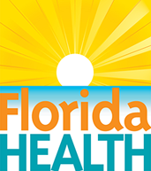

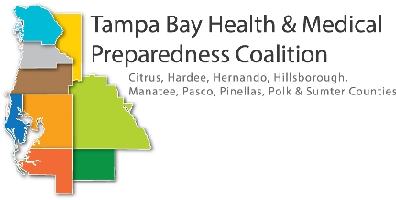

SPONSORED BY**:**