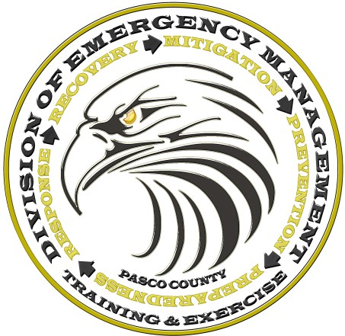

***Pasco County Emergency Operations Center***

# Healthcare Facilities

*Trainings & Exercises*

*January* — *March 2019*

|  |  |  |
| --- | --- | --- |
| **Date** | **Time** | **Name** |
| **1/10/2019** | 0800-1200 | **Comprehensive Emergency Management Plan (CEMP) Workshop** |
| **1/16/2019** | 0800-1200 | **Comprehensive Emergency Management Plan (CEMP) Workshop** |
| **1/30/2019** | 0800-1200 | **Healthcare Facilities Tabletop Exercise** |
| **02/6-8/2019** | 0900-1700 | **G-300 Intermediate ICS for Expanding Incidents** |
| **3/20/2019** | 0800-1200 | **Healthcare Active Shooter Plan Workshop** |
| **3/27/2019** | 0800-1200 | **CEMP Tabletop Exercise** |

## Trainings and exercises will be held at Pasco County Emergency Operations Center

To reserve spot(s) in any of the trainings or exercises contact Nicole Johnson with your Facility name, Individual(s) name(s), contact information.

Training and exercise fee apply. If you have yet to pay your training and exercise fee for the year it is

11.71 per bed. This covers all employees who wish to participate in the trainings and exercises.

*For more information regarding trainings/exercises contact:*

*Nicole Johnson at*

[cnjohnson@pascocountyfl.net](mailto:msaantiago@pascocountyfl.net) *or*

727-847-8137