**Ready For Emergencies**

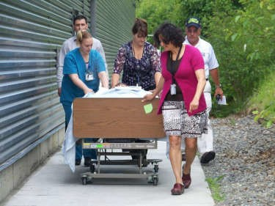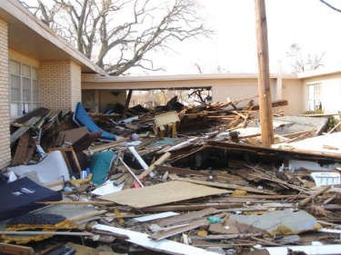

Home Care Hurricane Exercise

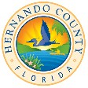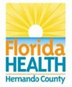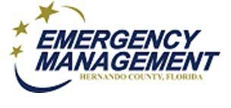

**Save the Date: July 23, 2019;** 1:00pm to 4pm

**Hernando County**

**Emergency Operations Center**

18900 Cortez Blvd.

Brooksville, FL 34601

**Exercise Purpose**

Hernando County Emergency Management and the Department of Health in Hernando County are hosting a hurricane exercise for agencies that serve home-based clients: ***Home Health, Nurse Registries, Hospice, Visiting Nurses, Dialysis, Medical Equipment and Oxygen*** providers.

**Benefits to Participating**

* Build your skills, activate your CEMP
* Educate your second-in-command
* Receive CMS exercise credit
* Learn from colleagues
* Join community alerts
* Register clients for Special Needs

**Who Should Attend?**

* Primary and back-up Leaders
* Supervisors and Key Staff
* Caregivers and Field Staff
* ***We encourage each agency to bring several staff members!***

**Please Register by July 19, 2019:**

* [Nina.Mattei@FLHealth.Gov](mailto:Nina.Mattei@FLHealth.Gov)
* **Questions**: Nina at 352-540-6822

