  - Friday, November 15, 2019  1st Annual TBHMPC Regional Meeting  Topic of discussion from subject matter experts include:  - Lessons learned from Matthew; A first-hand experience  - Patient Movement and Healthcare Transportation  - ESS (Emergency Status System) and AHCA  - Continuity of Operation Planning (COOP)  - The Continuum of Care; building resiliency within the healthcare community  - TBHMPC; State of the House. Where we are and where we’re going?  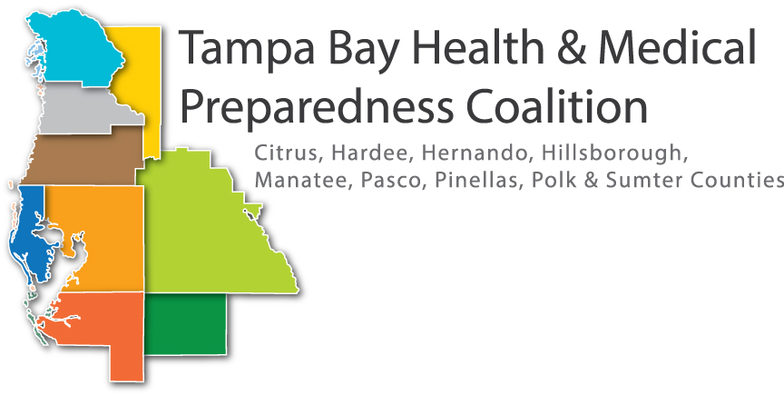 | Representatives from County Emergency Management  ____  Representatives from Department of Health  ____  Breakfast items & snacks provided  ____  Please Register At: http://www.tbhmpcrhcc2019.eventbrite.com/  Pasco- Hernando State College, Porter Campus at Wiregrass ranch  2727 Mansfield Blvd.  Wesley Chapel, FL 33543/  November 15, 2019  8:30 AM- 12:30 PM  Sign in/ Registration  8:00-8:30 AM

