ADVANCED BURN LIFE SUPPORT CLASS (ABLS)

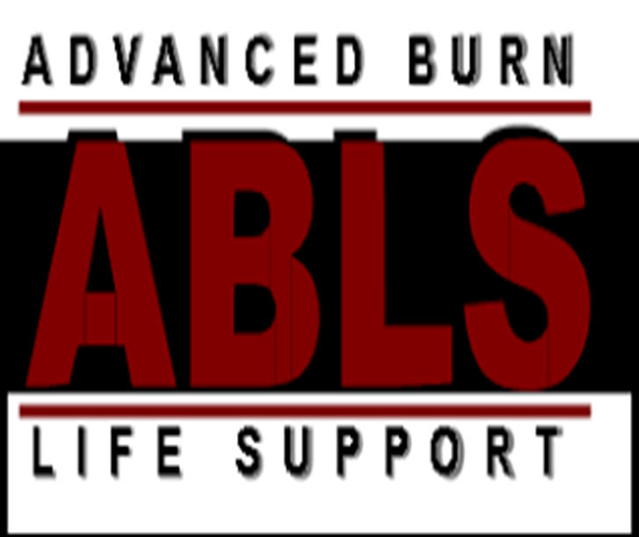

**Course Description**

Advanced Burn Life Support (ABLS) programs provide knowledge for immediate care of the burn patient up to the first 24-hours post injury. ABLS programs also support emergency preparedness and mass casualty incidents focusing on triage, burn survivability, prioritizing transport of patients, and patient treatment.

NOVEMBER 5, 2019 8-4:30

ADVENT HEALTH WAUCHULA CONFERENCE ROOM-2ND FLOOR

735 S. 5th Ave, Wauchula, FL 33873

RSVP by October 15, 2019 18 seats available

Questions? POC: Cathy Exendine, Director of Patient Care Services Advent Health Wauchula 863-767-8362