**Ready for Emergencies**

**Hospital Incident Command System**

|  |
| --- |
| **Save the Date:** March 10, 2020, 800am to 1230pm **Polk County Emergency Operations Center** 1890 Jim Keene Blvd. Winter Haven, FL 33880  ***HICS isn't Just for Hospitals!***  HICS isn't a mystery, it's a performance system for emergent and everyday operations. HICS gives you flexible, scalable, and team-based planning, response, and recovery. Lessons learned in responses and exercises are used to mitigate future losses. This team training is hosted by the Tampa Bay Regional Health and Medical Preparedness Coalition  **Who Needs to Attend?**  *Senior Leaders, Managers & Supervisors  *Incident Management Team Member  **Seats Available:** 40  **Questions:** 727-313-0625, [tbhmpc.logs@gmail.com](mailto:tbhmpc.logs@gmail.com) |
|  |
|  |
| Participants will be challenged to assess their plans, policies, and procedures related to the CMS Emergency Preparedness Rule requirements. Having identified strengths and areas of improvement within their Emergency Plans. |

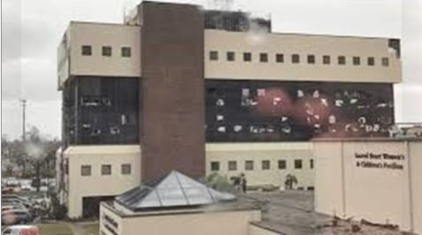

Hurricane Michael, FL 2018

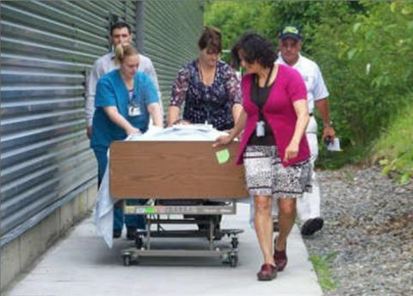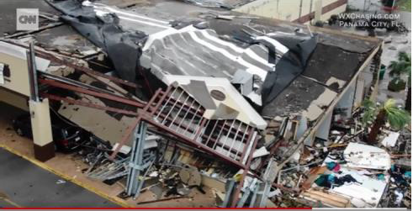

Hurricane Michael, FL 2018

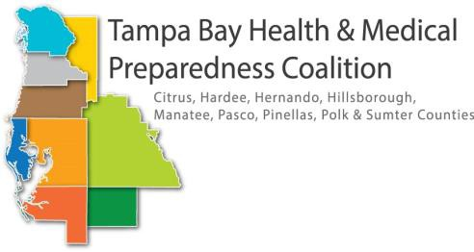

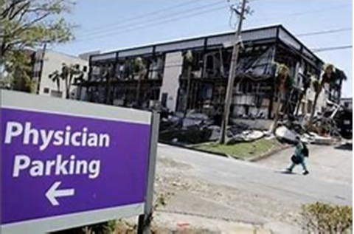

Hurricane Michael, FL 2018