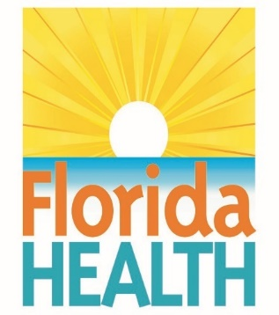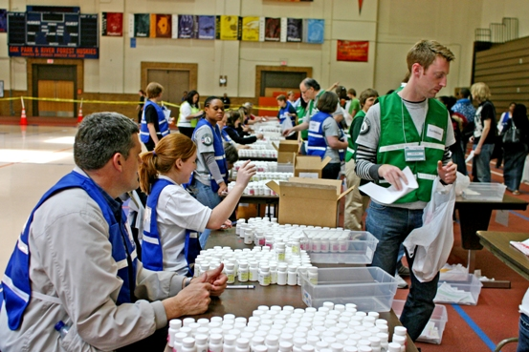

**Closed**

**Point-of-Dispensing Workshop**

The Florida Department of Health in Pasco County invites you to participate in our Closed POD Workshop. Participants will review and discuss Closed POD activation, operations, and planning. This workshop will aid in the continued growth of your agency’s closed dispensing plan. If you are currently not a Closed POD partner, we still encourage you to join to learn more about our program.

December 17th, 2019

1:30PM – 4:00PM

Mike Fasano Regional Shelter (Room #3)

11611 Denton Ave.

Hudson, FL, 34667

**Click Here to [Register](https://www.eventbrite.com/e/closed-point-of-dispensing-workshop-tickets-82972399681?aff=ClosedPOD)!**